# Work with GitHub

## Create Files

### Create files in your local directory

Before create files in GitHub for Windows

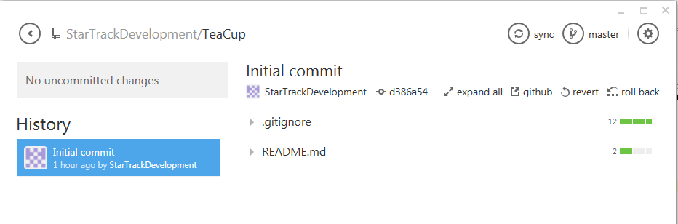

### You can open your repo directory in explorer

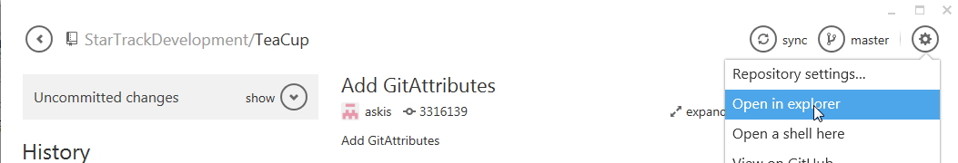

### Create or copy files to your local directory

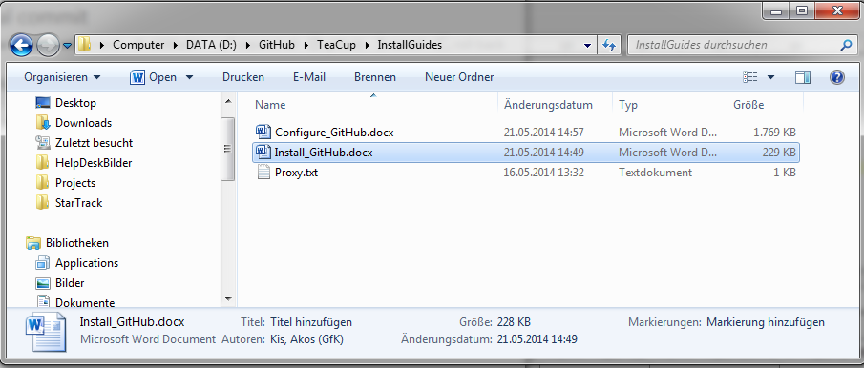

### Click on uncommitted changes

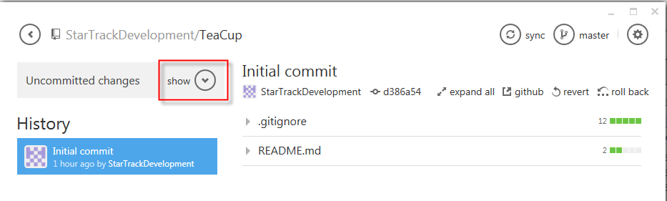

### The new files are there

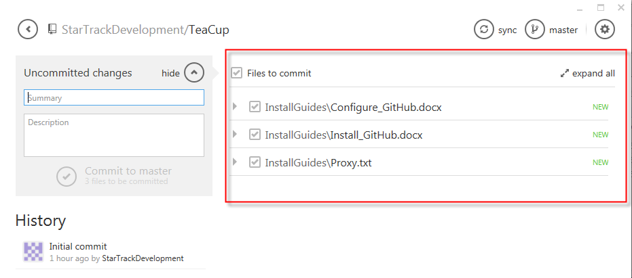

## Commit changes

### Add commit message

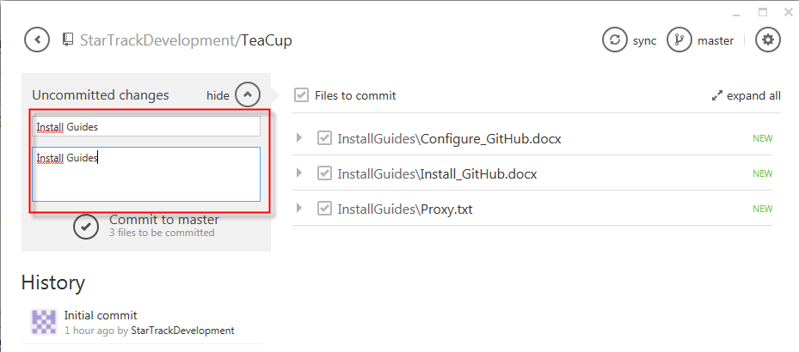

### Click commit to master

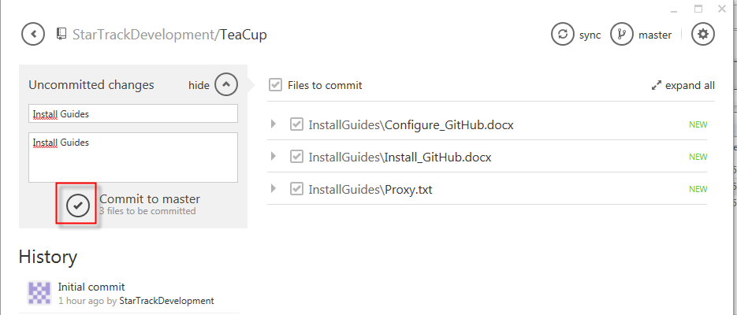

### We have commited the changes, but only local

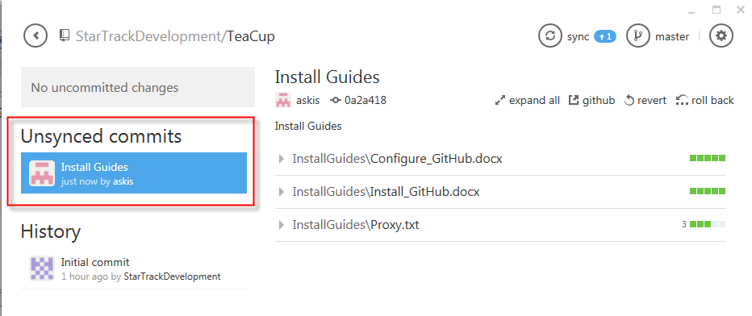

### Our changes does not yet exist on GitHub

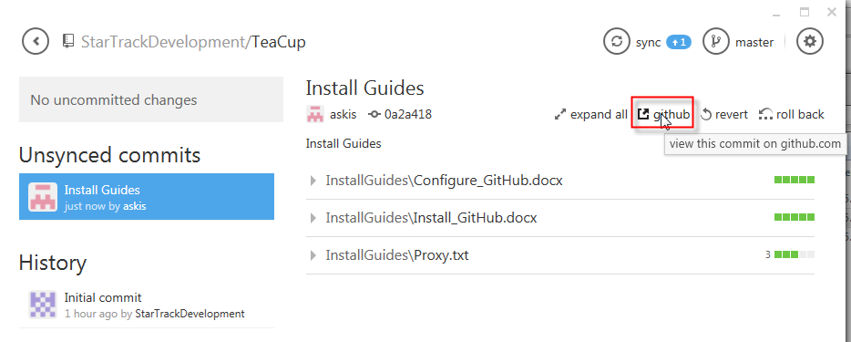

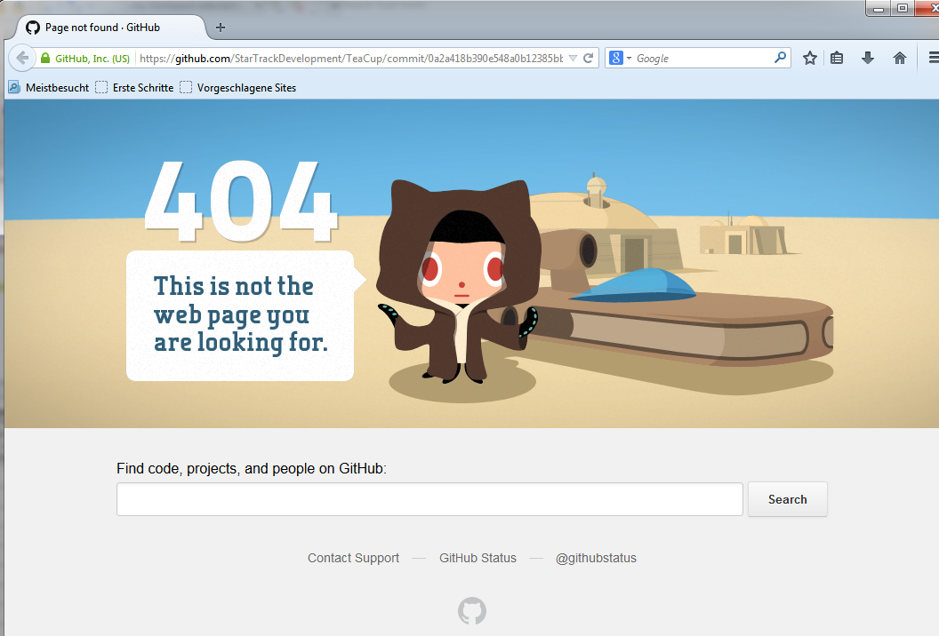

### Push our changes, click on sync

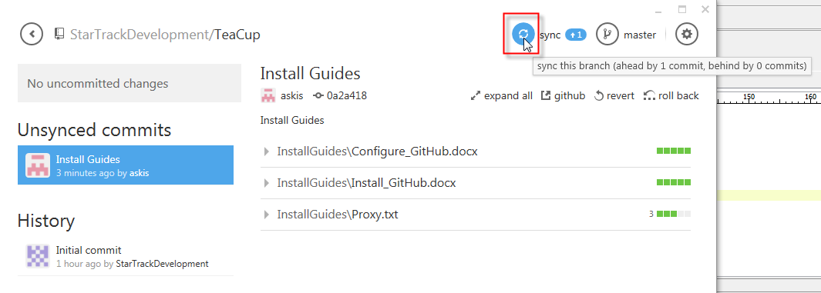

### Changes are in History now

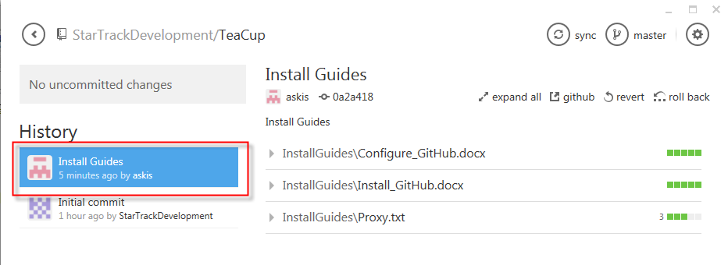

### We should see our changes online

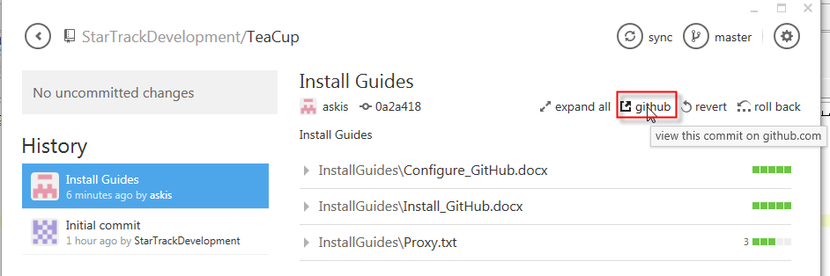

### Yes, we have install guides online now

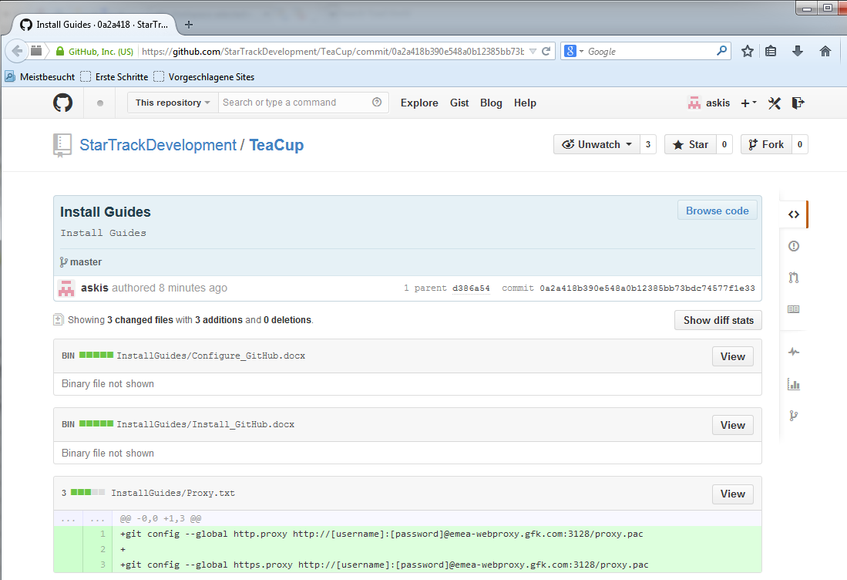

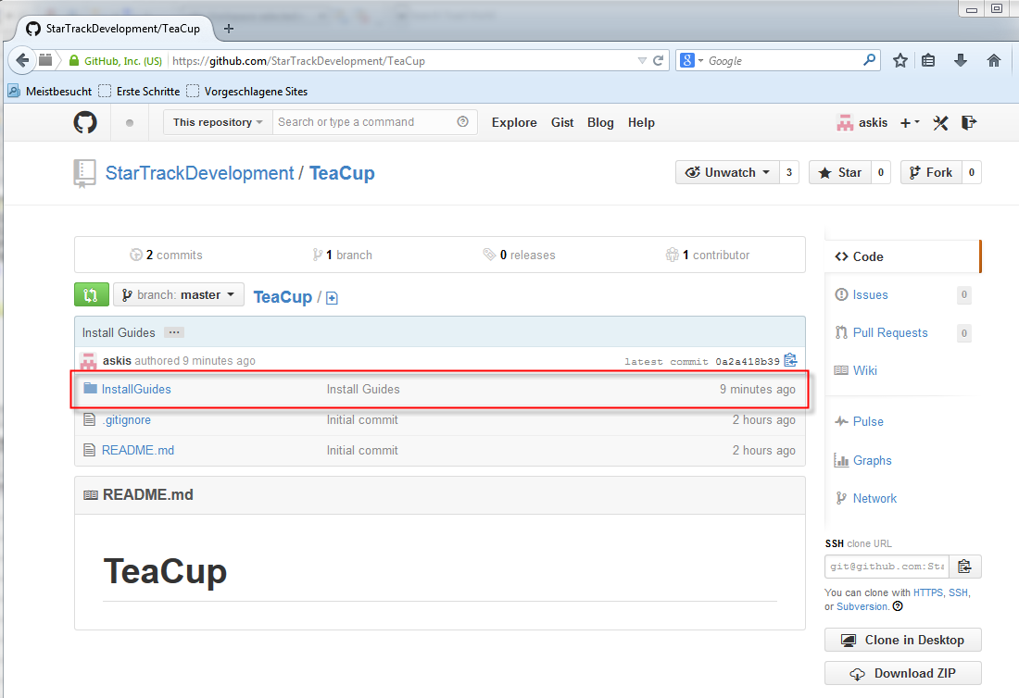

## Show difference

### Everything is synchronized, no changes exist

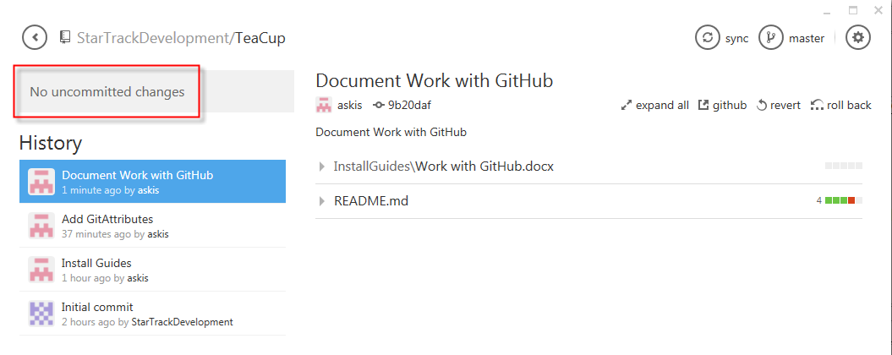

### Open ReadMe.md in any editor your choice

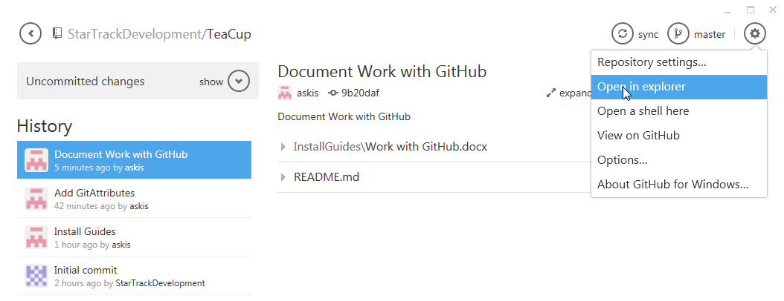

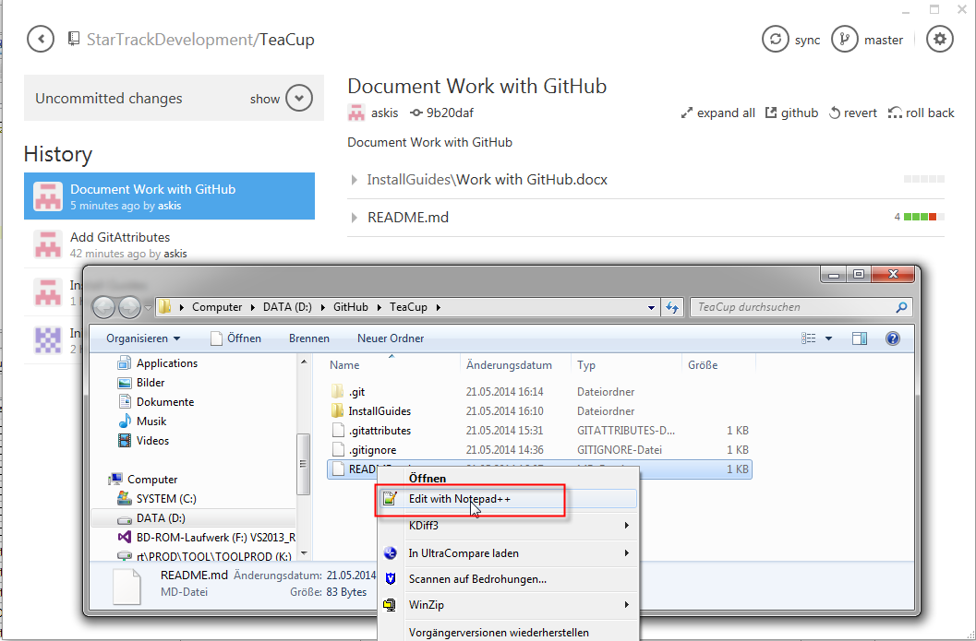

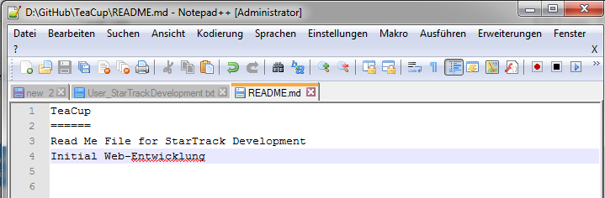

ToDos:

1. “Entwicklung” is German, should be Development
2. Delete line 3
3. Add new line with text “Diff example”

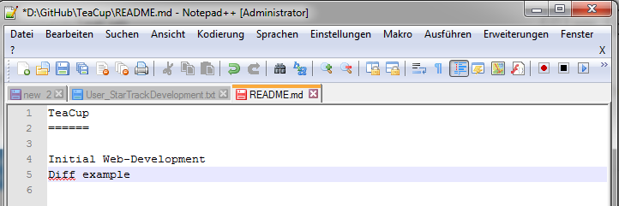

### Save the file and go back to GitHub for Windows

There are uncommitted changes

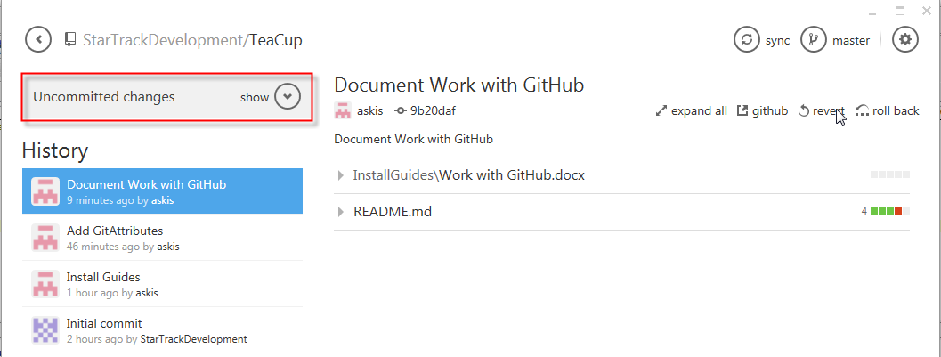

### Show them, click on “show”

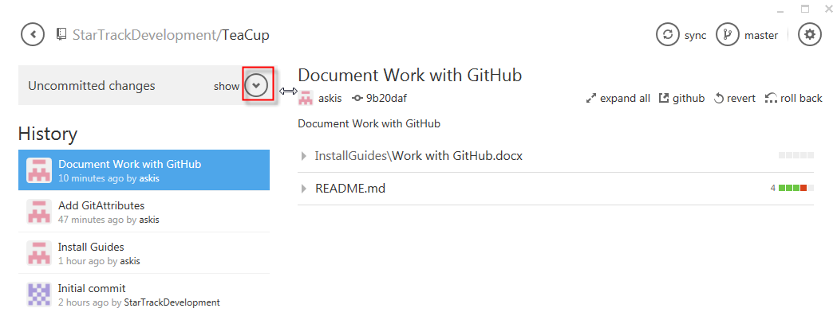

### Our ReadMe.md is there, git recognized that we made changes

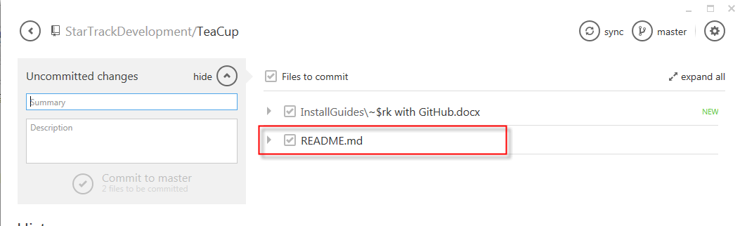

### Expand changes, click on the arrow

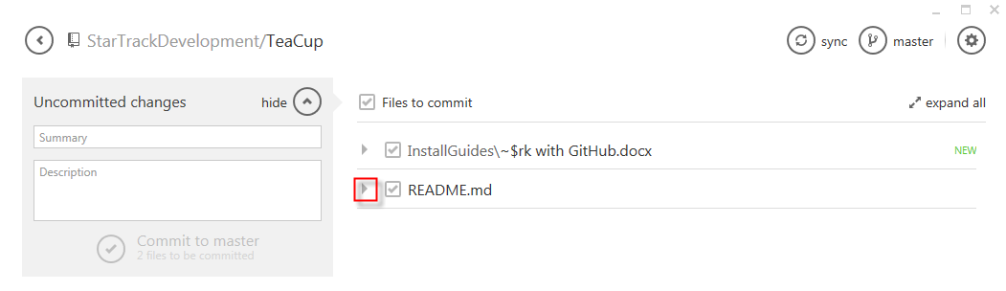

### All changes are shown

Red is deleted, green is new.

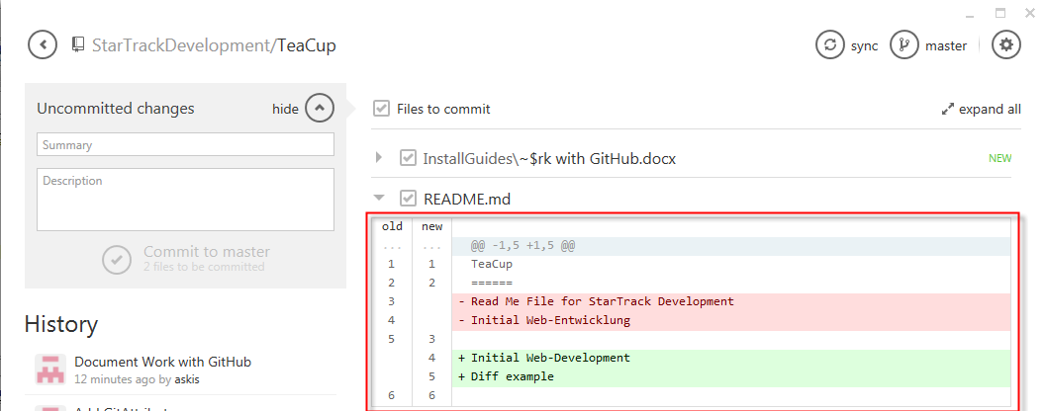

### Commit our changes and push it to the online repository

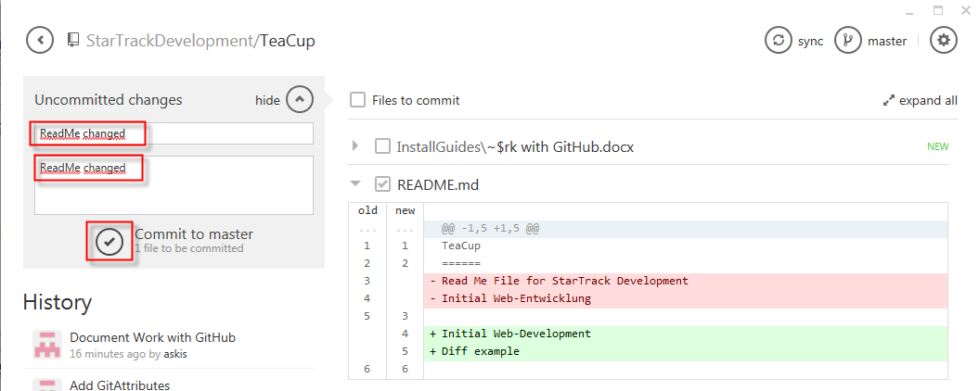

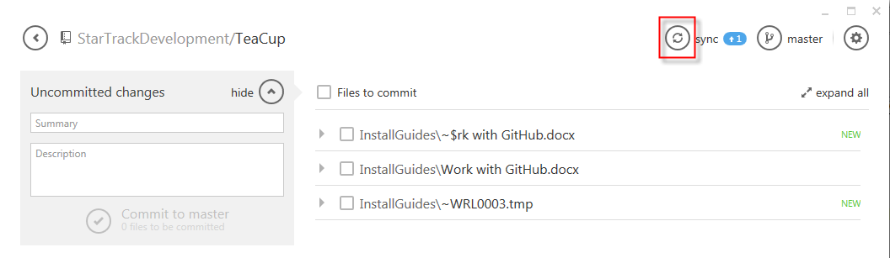

### Click on “ReadMe changed” in your History list

